1. 1st of all, operation means api/path/endpoint.
2. So, optional field operationId is used here 🡪 paths/{endpoint}/{http_method}/**operationId**.
3. **Usages**:
   1. When using code generator tool with OpenAPI Specification, the method names can be derived from the operationId given.
   2. When we want to establish a link b/w two operations (endpoints).   
      Like the response from this operation should be input to that operation which is possible if operation id is defined.
4. 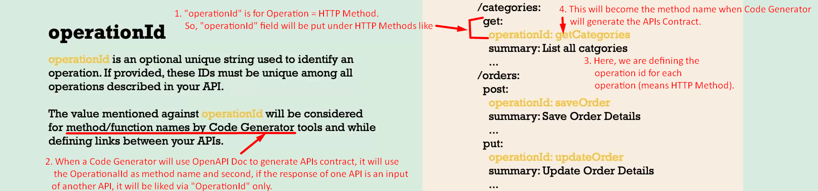
5. Now Mentor will define operation for each operation for every API.   
   